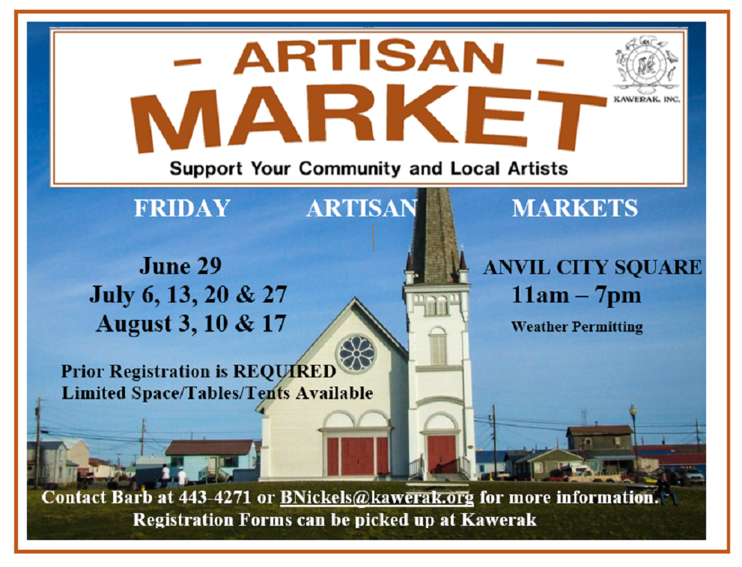
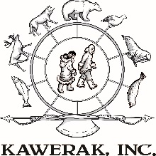

GUIDELINES FOR PARTICIPATION
Kawerak is excited to host a pilot project for an annual FRIDAY ARTISAN MARKET in Nome with our goal to increase sales for our regional Alaska Native artists.

- All local and regional vendors are welcome to complete and submit a Registration Form no later than June 21. There is no charge.

- Registered vendors will be notified by June 27 of their requested Market dates that were approved, based on allowable space.

- Vendor space will be allocated first to our Alaska Native artists, followed by a variety of other vendors until our allotted space is maximized.

- Registered regional artists may be provided airfare OR lodging for two nights as funds are available. Regional artisans will be chosen by lottery drawing if multiple registrations are received requesting the same Market dates. Artists should have a good inventory available for sale.

- A two day notice is required if you cannot participate on a date your registration was approved so that another vendor can be selected.

- Food vendors are welcome to submit a registration form for approval. Kawerak will follow the State of Alaska Cottage Food exemptions (non-potentially hazardous) that do not require a permit, as well as non-exempt items (potentially hazardous) that will require a permit. Food vendors will be sent additional information as they register.

- City of Nome Transient Merchants Sales Tax License Applications will be available at the Markets. Kawerak is not responsible for collecting or monitoring these applications.

- Kawerak has a limited amount of tents, tables and chairs. Those local vendors with a table are encouraged to bring their own. Tables must be manned at all times.

- Old St. Joe’s will not be open. Hanson’s does have a public restroom available. No electricity will be provided.

- Kawerak will require each participating vendor to fill out an anonymous evaluation that among other questions will ask your daily sales amount and if any ivory carvings were sold. This information is relative to evaluating the Markets overall success and for Kawerak to track what effects the recent ivory bans may be having.

- Walk-in vendors will not be accepted to set up in this reserved area unless all pre-registered vendor requests were able to be approved and there is space available.

REGISTRATION FORMS AVAILABLE AT KAWERAK, ON LOCAL NOME BULLETIN BOARDS, BERING STRAITS ARTS & CRAFTS FACEBOOK PAGE OR CAN BE EMAILED TO YOU

ARTISAN MARKET DATES:
□ July 5 □ July 12 □ July 21 □ August 2 □ August 9 □ August 16
* July 21st is the Nome Berry Festival with a Cruise Ship in Nome with 1000 passengers

QUESTIONS? Contact Barb Nickels at 434-1833 or BNickels@kawerak.org

