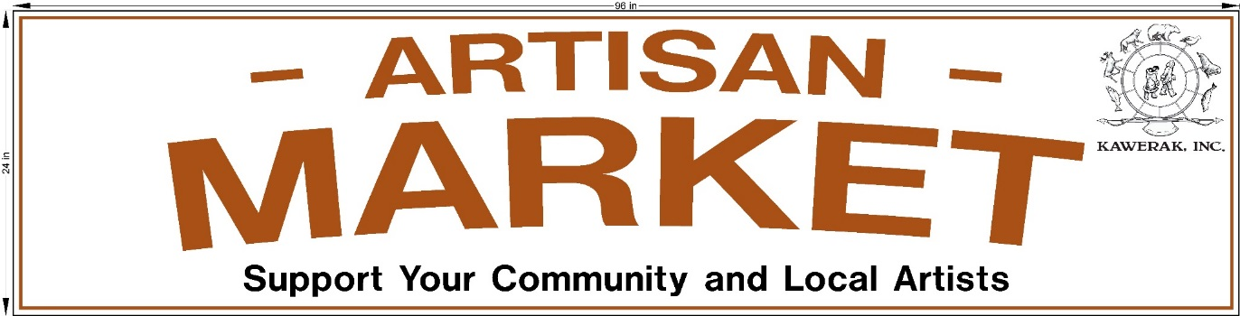

ANVIL CITY SQUARE - 11:00am – 7:00pm
Artisan Market Registration Form

Name (Print clearly) |  | Date
Organization, if applicable

Phone: | E-Mail Address:
Brief description of handcrafted items you will be selling
I request to reserve a: □ Half table □ Full table We will try to accommodate requests, but based on the number of vendors, space may be cut down to half tables. No electricity will be available. NO CHARGE
□ I can provide my own table and chair – We only have a small amount of tables available
Which ay’s do you wish to exhibit? You may ask for more than one.
□ July 5 □ July 12 □ July 21 □ August 2 □ August 9 □ August 16
* SUNDAY, July 21st is the Nome Berry Festival with a Cruise Ship in Nome with
1000 passengers
□ I reside in Nome □ I reside in the region and am requesting a scholarship
□ I request TRAVEL assistance □ I request LODGING assistance
*Scholarship funds are limited, please choose only one: Travel OR Lodging
Community coming from: ___________________________________

- If you have registered and have been notified you are on the list to use one of Kawerak’s tables/tents, you must call and cancel within 2 days if you cannot attend. This will allow someone else to be offered a table. Contact Barb at 434-1833 or leave a message.
- Market’s may cancel due to weather and the cancellation will be posted by 9:30am on Nome Post. Sunday, July 21st has a back up location of indoors at the Mini Convention
- We have a limited area to use at Anvil Square so all dates requested may not be available. We will contact you to let you know which dates are approved by June 28.
When set up, tables must be manned at all times.
- RETURN FORMS to Brenna Outwater at Kawerak Community Planning & Development, or E-Mail to Bnickels@Kawerak.org

