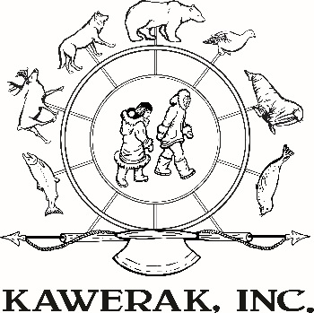
Brownfields Report Form
Thank you for taking the time to help us identify brownfields in your community. This information will help us better understand where future work may be needed. We may contact you with questions if we need more information about the site you have identified for consideration.

GENERAL INFORMATION
Name of Village: Your Name:
Your Phone: Your Email:
SITE INFORMATION
Where is the site? Please describe where the site is in reference to landmarks.

Who is the current owner of the property? Do you have land ownership documentation?

What structures are on the property, if any?

Historically, what was the site used for? Is the property or building used now?

What hazardous substance do you think the property is contaminated with? (ie. Diesel, Leaded Paint)
KNOWN OR PERCIEVED CONTAMINATES

What do you think caused the contamination?

Have there been any environmental assessments or clean-up activities on this site in the past?

Describe the site’s current condition. Is it actively used, abandoned, or closed to the public?
HEALTH CONCERNS AND PATHWAYS TO HUMAN HEALTH

How close is the site to other structures, subsistence resources, water bodies, or drinking water sources, etc.?

How are people impacted by the potential contaminates? Who would you say is most likely to be impacted? In other words, describe the health hazard and how it is impacting your community.
REUSE AND REDEVELOPMENT
How would you like to see this property reused?

How would the community benefit from this reuse option?

At what stage of development is the reuse plan for this site?
- Thinking about a plan
- Had a meeting about a plan
- Have a written reuse plan (attach to this form)
Are there any sources of funding for the reuse identified?
ATTACHMENTS
Please attach any of the following maps to indicate location:
Google map, Google Earth imagery, USGS Topography map
Please email or attach any photographs you may have of the site!
Please Submit Form To:
Kawerak Brownfield Program
P.O. Box 948
Nome, AK 99762
Email: klbourdon@kawerak.org
Phone: 907-443-5231

