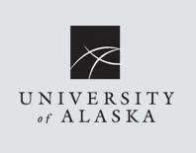

**_________________________________________** **_______________________________________**

**Youth’s Name** **Parent’s Name**

**_______________________________ ________________________**

**Signature of Parent/Guardian Date**

I authorize the **University of Alaska (UA), Kawerak, Inc.** and **Lemonade Day**, a project of Prepared 4 Life, permission to make still photographs, reproduce or publish photographs, recorded audio or video and use of verbal quotes, for the purpose of illustration, advertising, display and public relations purposes.

I also give Lemonade Day permission to use these completed audiovisual and print products for Lemonade Day promotional purposes without compensation or remuneration to me in any manner; in like and related regard, Lemonade Day will not charge or assess me any fees or service charges for my voluntary participation in this audiovisual product production.

Further, I relinquish and give to Lemonade Day all rights, title and interest, if any, I may have in the completed still photographs, video tapes or audio recordings, negative prints, reproductions and copies of the masters, negatives, recordings, duplicates, prints and verbal quotes for print.

**_____________________________________________**

**Address**

**_________________ _____________________**

**Phone Email**

Photo & Media Release