Community Name
Small Community Emergency Response Plan
Date
- Know the plan and know how your community will use it during an event.
- Practice this plan. For more information, contact DHS&EM Exercise Team at 907-428-7000.
- Hang this flipchart on the wall for easy access. Choose several different locations where your team can find it quickly when needed, such as next to fire alarms.
- Update contact information annually, or more often. Provide updates to the SEOC.
For disaster assistance 24 hours a day
Call the State Emergency Operations Center (SEOC)
1-800-478-2337/seoc@alaska.gov
SMALL COMMUNITY EMERGENCY RESPONSE PLAN
Planning Team
Community: | Community Name
Date: | Date
Planning Team Members:
COMMUNITY PLANNING TEAM
The State Emergency Operations Center (SEOC)
is available 24 hours a day to provide information and assistance
1-800-478-2337/seoc@alaska.gov
State Emergency Operations Center personnel can:
- Be a resource for emergency situations, pre-disaster planning and community preparedness
- Support local decision-making and actions as you direct and control emergency response
- Collect and share information with other jurisdictions and supporting entities, as needed
- Coordinate and provide resources for preparedness and response.
EMERGENCY RESPONSE LEADERSHIP
This guide is based on the Alaska Emergency Response Guide for Small Communities.  For more information, go to:  http://ready.alaska.gov/SEOC/  To request a hard copy, call 1-800-478-2337. | 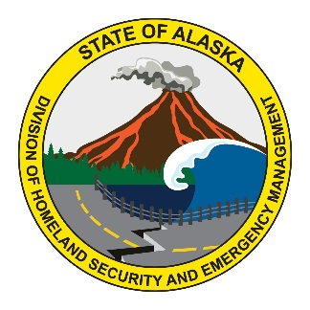
SEOC CONTACT INFORMATION 24 HOUR SUPPORT
Plan Distribution List
Contact | Agency | Physical Location | Phone | Email
Agency Copies
Ops | DHS&EM | SEOC | 1-800-478-2337 | seoc@alaska.gov
Paul Fussey | AST |  | 907-269-5682 | Paul.fussey@alaska.gov
N/A | Borough | N/A | N/A | N/A
PLAN DISTRIBUTION LIST
Every incident needs an Incident Commander (IC). The IC determines which positions are needed.

INCIDENT COMMAND SYSTEM (ICS) ORGANIZATION CHART
Title | Name | Agency | Phone(907) | Email
Incident Commander
Incident Liaison
Public Information Officer
Safety Officer
Planning Section Chief
Operations Section Chief
Logistics Section Chief
Finance Section Chief
Evacuation Specialist
Shelter Coordinator
Security Specialist
Medical Specialist
INCIDENT COMMAND CONTACT SHEET
Incident Command System (ICS) Roles and Responsibilities
Position | Duties and Responsibilities
Incident Commander | Manages the people and resources to respond to the incident.
Incident Liaison | Coordinates with community and outside organizations involved in the incident.
Public Information Officer | Provides information to the public and media regarding the event in accordance with the IC.
Safety Officer | Assures safety issues are mitigated, announced and addressed.
Planning Section Chief | Gathers and analyses incident information; conducts Planning Meetings, and prepares Incident Action Plans (IAP).
Operations Section Chief | Responsible for incident tactical operations – actions, personnel, resources, and staging areas.
Logistics Section Chief | Obtains requested incident facilities, services, and materials.
Admin Section Chief | Tracks costs and manages incident finances and personnel issues.
Evacuation Specialist | Develops plan to shelter in place or move individuals to a safe location.
Shelter Coordinator | Sets up, operates and closes shelter(s) and/or coordinates shelter activities.
Security Specialist | Keeps unauthorized personnel from physically accessing resources, buildings, or confidential information.
Medical Specialist | Provides and/or coordinates emergency health care services.

ICS ROLES AND RESPONSIBILITIES

State Emergency Operations Center
1-800-478-2337

IF YOU HAVE ADVANCE WARNING TAKE PRECAUTIONARY MEASURES
Take advantage of every opportunity if you have warning of a possible event: Don’t wait!
ISSUE | IMMEDIATE ACTIONS |  | PARTNERS | CONTACT INFORMATION
Take immediate action | - Size –up th current situation  - Assess potential risks  - Review and implement local plans |  | SEOC | State Emergency Operations Center  1-800-478-2337
Notify partners  IF YOU HAVE ADVANCE WARNING TAKE PRECAUTIONARY MEASURES | - Notify or recall city, tribal, emergency personnel  - Notify regional entities (Borough, Regional Corps)  - Notify the SEOC of possible concerns |  | City
 |  |  | Tribe
Native
Non-Profit
Keep everyone safe | - Take actions to minimize risks to life, health, safety  - Notify health aides to identify late term pregnant women, elderly, disabled and at-risk patients  - Secure critical infrastructure: communications, power, water, airport and/or runway  - Ensure residents are safe and secure  - Notify residents in remote areas, when possible  - Advise residents to take precautionary measures  - Ensure critical vehicles and equipment are fueled  - Check status of critical infrastructure & resources |  | AST
 |  |  | SEOC | 1-800-478-2337
 |  |  | American Red Cross (ARC) | Toll-free: 888-345-HERO (4376)  Main office: 907-646-5401  Press Option 3 for either number.
Inform everyone | - Inform leaders, responders, and critical personnel  - Inform community members  - Give clear information, desired actions, warnings |  | PIO

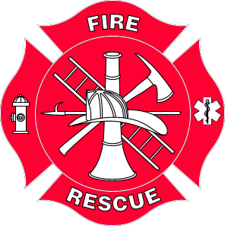
Fire Department  Phone # | Village Public Safety Officer  Phone # | Alaska State Troopers  Phone #

THE FIRST 4 HOURS BEGIN RESPONSE

Life, health and safety are most important.
ISSUE | IMMEDIATE ACTIONS |  | PARTNERS | CONTACT INFORMATION
Take immediate action | - Continue sizing up the situation as it changes  - Begin Search and Rescue (SAR) as necessary  - Local efforts start with VPSO, Fire (if available)  - Major SAR is coordinated through AST  - Call resources: medical, public safety, fire, other |  | AST
 |  |  | SEOC | State Emergency Operations Center  1-800-478-2337
Gather resources | - Recall, city, tribal, emergency personnel  - Contact regional entities (Borough, Corporations)  - Contact mutual aid partners and the State  - Track response costs for possible $ assistance  Ask SEOC for technical assistance, as needed
 |  |  | SEOC | 1-800-478-2337
Keep everyone safe  THE FIRST 4 HOURS BEGIN RESPONSE | - Secure incident scene and minimize hazards.  - Work closely with SEOC and ARC on shelter/evac  - Work with clinic and regional health corporation to develop strategies for at-risk groups  - Identify evacuation routes away from harm  - Work with Red Cross to open and supply shelters  See Sheltering and Evacuation pages for details  - Notify residents, particularly those at-risk |  | Safety
 |  |  | Health Aide
 |  |  | SEOC | State Emergency Operations Center  1-800-478-2337
 |  |  | American Red Cross (ARC) | Toll-free: 888-345-HERO (4376)  Main office: 907-646-5401  Press Option 3 for either number.
Assess hazards and damages | - Check status of critical facilities  - Contact areas not reporting in  - Assess emergency communications systems  - Declare a local state of emergency, if needed  See Disaster Declarations page for details |  | - Identify affected areas and operational status of critical services  - Take actions to minimize damages, maximize safety, ensure communications
Inform everyone | - Get critical information to leaders and responders  - Inform community members

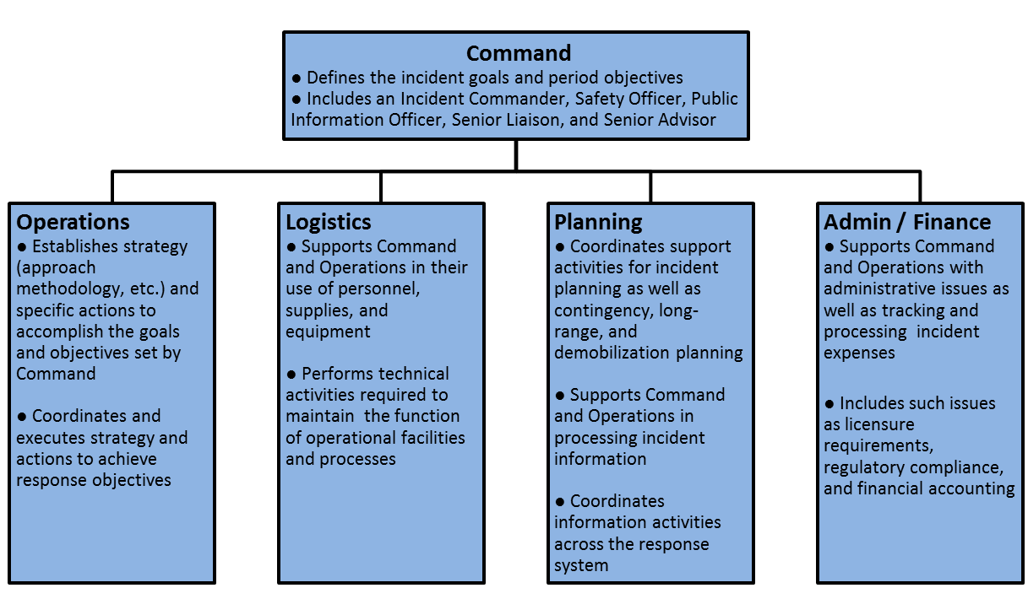
THE FIRST 12 HOURS PREPARE FOR SUSTAINED RESPONSE

Life, health and safety remain your first priority. Additional actions become increasingly important.
ISSUE | IMMEDIATE ACTIONS |  | PARTNERS | CONTACT INFORMATION
Activate Team | - Establish Emergency Operations Center (EOC) or Incident Command Post (ICP) |  | IC
Set schedules | - Consider 14-day operational period  - Schedule workers so they have adequate rest  - Set regular times for locals to report status and to request State/Federal assistance  - Track response costs for each response function  Ask SEOC for technical assistance, as needed; early help from State Disaster Assistance staff increases recoupment of costs |  | Operations
 |  |  | Safety
 |  |  | Finance
 |  |  | SEOC | State Emergency Operation Center  1-800-478-2337
Address shortfalls | - Assess critical resource shortfalls  - Request initial mutual aid and State support |  | Liason
Prepare transportation routes | - Assess road and transportation conditions  - Designate primary and secondary travel routes  - Plan alternative methods for moving resources  - Prioritize and implement debris clearance  - Have traffic control for critical routes |  | - Identify affected areas and operational status of critical services  - Take actions to minimize damages, maximize safety, and ensure communications
Continue any sheltering and evacuation | - Assess conditions at shelter  - Arrange for continuous staffing and resupply  - Coordinate with all resources for any evacuation actions |  | American Red Cross (ARC) | Toll-free: 888-345-HERO (4376)  Main office: 907-646-5401  Press Option 3 for either number.
 |  |  | SEOC | 1-800-478-2337
Update everyone | - Update leaders, responders, and critical personnel (if possible, set schedule)  - Continue to inform community members |  | - Give specific information: safety precautions; where to get food, water, shelter; what to do with pets; and other essentials
THE FIRST 12 HOURS PREPARE FOR SUSTAINED RESPONSE

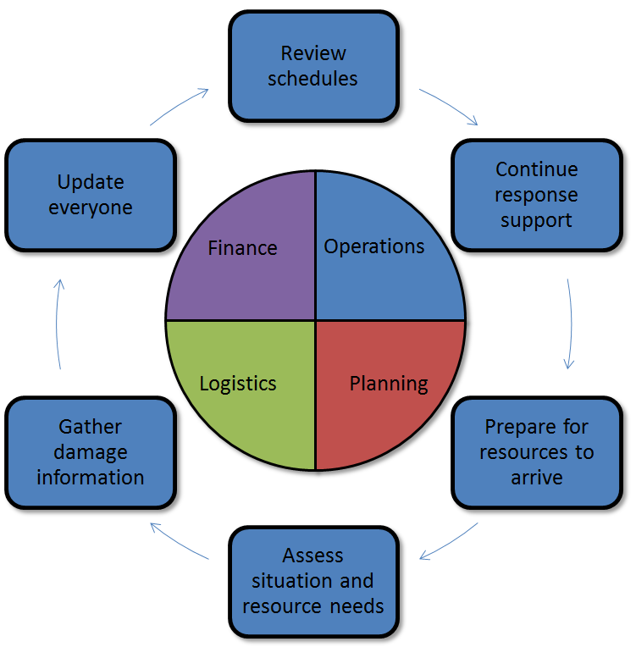
THE FIRST 24 HOURS SUSTAIN EMERGENCY RESPONSE OPERATIONS

New issues are likely to emerge. As responders and leaders become tired, attend to safety and decision making. Try to stay updated on new information and needs so that you can provide reports and request assistance.
ISSUE | IMMEDIATE ACTIONS |  | PARTNERS | CONTACT INFORMATION
Review schedules | - Include adequate rest in work schedules for EOC, rescue, shelter, security and others  - Check that response costs are being tracked  Ask SEOC for technical assistance, as needed |  | SEOC | State Emergency Operations Center  1-800-478-2337
Continue response support | - Support on-scene incident management  - Identify any materials, equipment, and workers needed to continue operations  - Seek resources from mutual aid partners and the state as needed |  | IC
 |  |  | Operations
Prepare for resources to arrive | - Designate staging areas  - Plan for incoming support personnel: rest, sleeping, and work space; meals; etc. |  | Logistics
Assess situation and resource needs | - Assess situation status and resource needs of affected facilities (include sites of historical or cultural significance)  - Request resources as required |  | Liaison
Gather damage information  THE FIRST 24 HOURS SUSTAIN EMERGENCY RESPONSE OPERATIONS | - Gather and report information about known damages in affected areas  - Collect information on homes in affected areas and, as possible, other structures  See Damage Assessment page for details |  | SEOC | State Emergency Operations Center  1-800-478-2337
 |  |  | American Red Cross (ARC) | Toll-free: 888-345-HERO (4376)  Main office: 907-646-5401  Press Option 3 for either number.
Update everyone | - Provide information on regular schedule to leaders and community residents  - Get information out in more than one way |  | - Use all available means that work for your community: briefings; meetings; radio; VHF; flyers at store, school, city/tribal office, post office, etc.

State Emergency Operations Center
1-800-478-2337

Red Cross of Alaska
Toll-free: 888-345-HERO (4376)
Main office: 907-646-5401
Press Option 3 for either number.
THROUGH 48 HOURS STABILIZE SUPPORT FOR AFFECTED AREAS

Stabilize support for affected areas and resume services in unaffected areas, as appropriate.
ISSUE | IMMEDIATE ACTIONS |  | PARTNERS | CONTACT INFORMATION
Review worker status | - Make sure work schedules continue to provide adequate rest for workers |  | SEOC | State Emergency Operations Center  1-800-478-2337
Continue response support | - Support on-scene incident management and responders  - Seek resources from mutual aid partners and the state as needed: order required materials, equipment, and workers
Meet resource needs | - Identify new resource needs  - Process outstanding resource requests  - Plan for additional incoming response, regional, and state/federal agency personnel  - Non-local personnel who were originally self-sufficient may now need additional support  - Check cost-tracking for all resources
Establish distribution systems | - Establish distribution systems for persons not in sheltering facilities as needed for:  - Emergency drinking water  - Food, clothing, and other essentials
Assess shelter operations | - Continue to work with Red Cross  - Begin to plan shelter closures or plan for longer shelter operations |  | American Red Cross (ARC) | Toll-free: 888-345-HERO (4376)  Main office: 907-646-5401  Press Option 3 for either number.
Assess/report damages | - Continue local damage assessments with emphasis on critical facilities |  | SEOC | State Emergency Operations Center  1-800-478-2337
Update everyone | - Review and revise situation reporting  - Continue regularly scheduled public information updates to leaders and residents |  | - Update steps the public should take, available services and key contact information, ways they can help, and any necessary rumor control

THROUGH 48 HOURS STABILIZE SUPPORT FOR AFFECTED AREAS

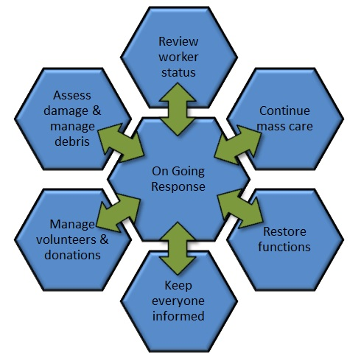
THROUGH 72 HOURS SUSTAINED OPERATIONS

For significant events, begin the transition from immediate response to sustained operations.
For smaller events, begin to prepare for certain operations to end. Other actions, such as damage assessment, will increase.
ISSUE | IMMEDIATE ACTIONS |  | PARTNERS | CONTACT INFORMATION
Review worker status | - Make sure work schedules continue to provide adequate rest for workers |  | SEOC | State Emergency Operations Center  1-800-478-2337
Support response | - Support on-scene incident management  - Support clinic and other critical resupply
Meet  resource needs | - Identify new resource needs  - Process/ follow up on outstanding resource requests  - Plan for additional incoming response, regional, and state/federal agency personnel  - Non-local personnel who were originally self-sufficient may now need additional support  - Track response costs for possible $ assistance
Establish distribution systems | - Establish distribution systems for:  - Emergency drinking water  - Food and other essentials
Manage debris | - Move from emergency clearance of essential roadways to debris removal, if possible |  | - Track staff time and equipment costs for possible reimbursement above normal expenses
Assess shelter operations | - Evaluate shelter and mass-care needs in collaboration with the Red Cross  - Consider longer-term needs of at-risk groups |  | American Red Cross (ARC) | Toll-free: 888-345-HERO (4376)  Main office: 907-646-5401  Press Option 3 for either number.
Manage volunteers and donations | - Assist Red Cross or VAL to manage volunteers & donations  - If possible, assign a position in EOC or IMT  - Let the public know what is and isn’t needed |  | State VAL | Ask for State Voluntary Agency Liaison at State Emergency Operations Center  1-800-478-2337
Report damages | - Transition to initial damage assessments required by State and FEMA |  | SEOC | 1-800-478-2337
Update everyone | - Continue regularly scheduled public information updates to leaders and residents |  | - Include information on returning home or moving from shelters; donations; applying for disaster assistance; critical timelines and desired actions

THROUGH 72 HOURS SUSTAINED OPERATIONS

For significant events, begin the transition from immediate response to sustained operations.
For smaller events, begin to prepare for certain operations to end. Other actions, such as damage assessment, will increase.
ISSUE | IMMEDIATE ACTIONS |  | PARTNERS | CONTACT INFORMATION
Review worker status | - Check that work schedules continue to provide adequate rest for workers  - Provide for responder mental health support  - Track response costs for possible $ assistance |  | SEOC | State Emergency Operations Center  1-800-478-2337
Continue  mass care | - Locate and open relief supply and food distribution points outside of shelters  - Provide support for and work to relocate those who need special support and care |  | American Red Cross (ARC) | Toll-free: 888-345-HERO (4376)  Main office: 907-646-5401  Press Option 3 for either number.
Restore functions | - Work with Red Cross and others for unmet immediate needs and recovery needs  - Coordinate with local businesses to open as quickly as possible
Manage volunteers and donations | - Prepare to manage volunteers & donations  - If possible, assign a position in EOC or IMT  - Let the public know what is and isn’t needed |  | State VAL | Ask for State Voluntary Agency Liaison at State Emergency Operations Center  1-800-478-2337
Assess damages and manage debris | - Begin widespread safety/damage assessments of public infrastructure, homes and businesses  - Continue to collect, transport, segregate, recycle and dispose of disaster debris |  | SEOC | 1-800-478-2337
Update everyone | - Develop and distribute a Disaster Fact Sheet to update residents, responders, and media |  | - Providing information on disaster assistance programs and on what to expect become increasingly important. Continue to work with the SEOC.

BEYOND 72 HOURS TRANSITIONING TO RECOVERY

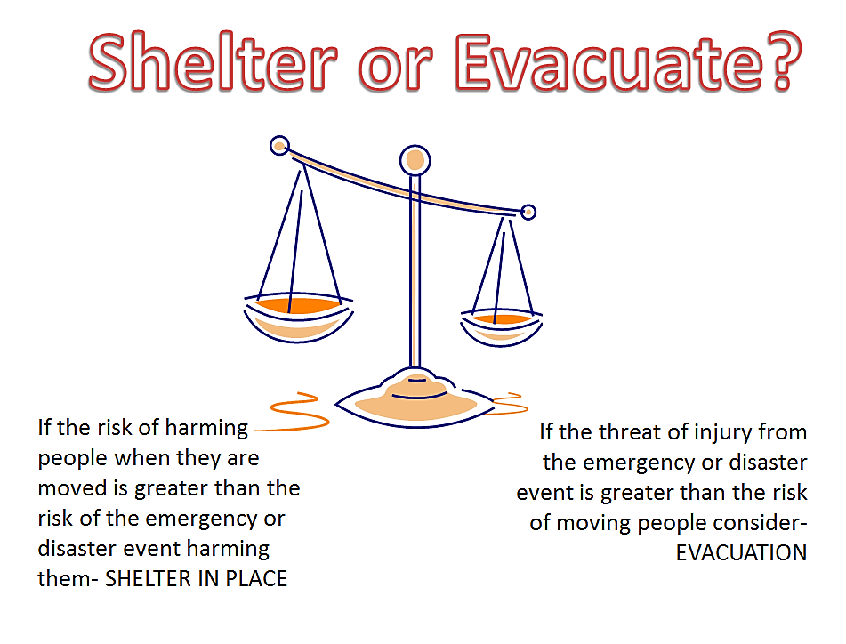
Coordinate with Red Cross for shelter support.
Toll-free: 888-345-HERO (4376)\ Main office: 907-646-5401
Press Option 3 for either number.

Community may be responsible for costs of evacuation away from the community.
If safe to do so, contact SEOC in advance. 1-800-478-2337
SHELTERING vs. EVACUATION CRITICAL DECISIONS AND ACTIONS

Events such as floods and storms will require decisions on whether to stay put (“shelter-in-place”), move to a shelter, or evacuate outside the community. These decisions are made by the authorized local official. Report the situation to the SEOC.
ISSUE | IMMEDIATE ACTIONS |  | PARTNERS | CONTACT INFORMATION
Decide best action | - Get the best information possible on situation  - Assess risks and decide to shelter-in-place, move to a shelter, or evacuate outside the community (may be limited to certain areas)  - Safety is the primary concern: Is it safer to stay in place or move residents?  - Use the SEOC as a resource  - Seek expert opinion: SEOC, NWS, AST, DOF  - Estimate time needed to move affected residents |  | Evacuation Specialist
 |  |  | National Weather Service | 907-546-2215/266-5105
 |  |  | Alaska State Troopers
 |  |  | DOF
 |  |  | American Red Cross (ARC) | Toll-free: 888-345-HERO (4376)  Main office: 907-646-5401  Press Option 3 for either number.

TIMELINE | SHELTER-IN-PLACE WITHIN COMMUNITY | VS. |  | EVACUATION AWAY FROM COMMUNITY
Planning Phase | - Determine areas or facilities at risk. Prioritize:  - Areas with immediate life safety threats  - Medically fragile, elderly, disabled, late-term pregnancies, young children, home-bound  - Plan and check on evacuation routes.  - Determine how and where residents will be picked up, if they need transportation  - Estimate number of people who will need shelter  - Coordinate with Red Cross for shelter support |  | Evacuation by air or other means outside the community is an emergency measure to save lives in immediate danger, considered after other strategies.  - Safety is primary. Plan, check on evacuation routes  - Coordinate transportation: vehicles, routes, drivers  - Community may be responsible for costs of evacuation away from the community. Contact SEOC in advance, if safe to do so.
Advance Warning | - Provide advance warning. Coordinate precautionary measures for at-risk populations  - Prepare temporary shelters  - Coordinate transportation: vehicles, routes, drivers  - Coordinate with schools on closures, sheltering |  | - Notify all residents of potential actions, including school and other facilities  - Coordinate transportation: vehicles, routes, drivers  - Advise receiving jurisdiction of potential evacuation  - Coordinate with school/shelters; check supplies
Movement/ Evacuation Phase | - Announce move to shelter to special needs populations, assisting as needed  - Notify public using available warning systems and media. Give evacuation areas and critical information (see reverse for details)  - Staff and open temporary shelters  - Have a system for documenting shelter residents  - Provide situation reports to region and SEOC |  | - Advise receiving jurisdiction of evacuation, timelines, numbers, and other needs  - Announce evacuation to special needs populations, assisting if needed  - Notify public using available warning systems and media. Give evacuation areas, critical information  - Have a system to record names, contact numbers and addresses of evacuees and escorts  - Provide situation reports to region and SEOC
SHELTERING vs. EVACUATION CRITICAL DECISIONS AND ACTIONS

SHELTERING AND EVACUATION NOTIFYING RESIDENTS

Keeping the community informed throughout advance warnings, disaster response, and the return home for sheltered or evacuated residents, planning ahead and are two essential activities.
ISSUE | IMMEDIATE ACTIONS |  | PARTNERS | CONTACT INFORMATION
Informing Residents of Shelter and/or Evacuation
General instructions for residents | Specific instructions will vary with the situation.  - Give current, specific information  - Keep listening to the radio or VHF (or other source of information) for updated instructions |  | SEOC | State Emergency Operations Center  1-800-478-2337
 |  |  | PIO
Advance warning | - Take precautionary actions, such as moving at-risk residents, protecting valuables, securing loose objects, boarding windows. If time permits and safe to do so  - Encourage residents to gather supplies (see  Alaska Emergency Response Guide & ready.alaska.gov |  | AST
 |  |  | Safety
Moving to shelters or evacuation points | - Provide specific instructions for moving to shelter or evacuation points: Use caution when moving, gather at specific locations or landmarks.  - Include specific information on pets (animal sheltering plan): locations receiving pets; shelters accepting pets; supplies to include for pets; etc.  - Inform residents where to get information for return. |  | ARC | Toll-free: 888-345-HERO (4376)  Main office: 907-646-5401  Press Option 3 for either number.
 |  |  | Items to bring to shelter or evacuation point:
 |  |  | - Identification  - Clothes (3 days)  - Personal sup-plies, toiletries |  | - Medications/  Prescriptions (3 days)  - Med. equipment | - Contact info  - Games  - Essentials for self and family
Returning Evacuees Safely Home
Ensure ability to return safely | Before evacuees are returned home, be sure:  - Threat has resolved  - Enough debris removed so roads/bridges safe to use  - Downed power lines cleared; ruptured utility lines repaired (service may still be out); other safety hazards addressed  - Structures inspected and safe for occupancy  - Adequate water available for firefighting |  | SEOC | 1-800-478-2337
 |  |  | PIO
Coordinate evacuee return | - Update agencies and workers on return plan  - Coordinate messaging to evacuees  (For more information, see Evacuation – Returning Home tab |  | SEOC | 1-800-478-2337
 |  |  | ARC | Toll-free: 888-345-HERO (4376)  Main office: 907-646-5401  Press Option 3 for either number.
Give evacuees return information | - Coordinate messaging to evacuees with shelter  - Include in messages information on:  - Using caution in reactivating utilities &appliances  - Health hazards  - Cleanup instructions; debris removal and disposal  - Documenting and minimizing damages |  | SEOC | 1-800-478-2337
 |  |  | PIO

SHELTERING AND EVACUATION NOTIFYING RESIDENTS

COMMUNITY MAP LEGEND
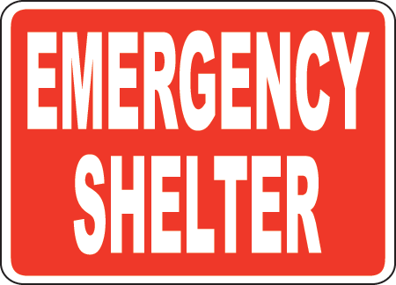 | EMERGENCY SHELTER | 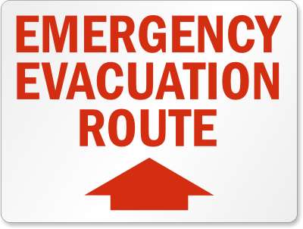 | EMERGENCY EVACUATION ROUTE
 | HOSPITAL or CLINIC | EOC | EMERGENCY OPERATIONS CENTER
COMMUNITY MAP

Contact American Red Cross of Alaska for support planning and operating shelters, 1-888-345-4376
TIMELINE | SHELTER OPERATIONS
Before event | - Work with ARC to develop shelter plan:  - Identify and document shelter(s) in RC database  - Train shelter manager and others | - Estimate essential supplies and staff based on size  - Have a way to register each person in the shelter  - Test cell phone communications, if used
During event | - Notify, request support from state/vol. agencies  - Establish and maintain contact with Red Cross  - Order supplies and personnel  - Provide shelter report  - Check building status and inventory and document  See ARC Facility/Shelter Opening Checklist (reverse)  - Assess amount of food on-site, feeding options  - Prepare rooms for occupancy  - Recruit shelter staff and/or volunteers, as needed  - Provide for security in and outside shelters (VPSO) | - Work with clinic/public health for medical support  - Plan for needs of vulnerable, at-risk populations – including language, medical, transportation issues  - Implement shelter rules and guidelines  - Begin beverages, snacks, meals as soon as possible  - Arrange for pet care, if needed  - Provide initial information and updates (radio, VHF, PA, in-person, etc.)  - Register and track each shelter resident  - Document all actions and costs
After event | - Document and release residents from shelter  - Clean and conduct post-shelter inspection | - Replenish supplies  - Evaluate operations and modify shelter plan for future use

Primary Shelter Information
Shelter |  | Location |  |  | Phone |  | Contact to OK Use and Open Shelter
 |  |  |  |  |  |  | Primary Name:
 |  |  |  |  |  |  | Number:
Restrictions on use/availability, if any: |  |  |  |  |  |  | Backup Name:
 |  |  |  |  |  |  | Number:
Bed Capacity | # Showers |  | # Bathrooms | ADA Accessibility |  | Emergency Generator |  | Kitchen Facilities

Alternate Shelter Information
Shelter |  | Location |  |  | Phone |  | Contact to OK Use and Open Shelter
 |  |  |  |  |  |  | Primary Name:
 |  |  |  |  |  |  | Number:
Restrictions on use/availability, if any: |  |  |  |  |  |  | Backup Name:
 |  |  |  |  |  |  | Number:
Bed Capacity | # Showers |  | # Bathrooms | ADA Accessibility |  | Emergency Generator |  | Kitchen Facilities

SHELTERING OPERATING THE SHELTER

Evacuation Routes to Shelters within Community
Routes are marked on Evacuation Community Map tab
For information about shelter and evacuation decisions; see Sheltering vs. Evacuation tab Information in red may not be known in advance
The column in red is for information as it develops during and after the event.
Evacuation Routes
Route Name | Start Location | Finish Location | Distance | Route Condition | Required Debris Removal/ Transportation Assistance

Routes and Air Transport Information for Evacuation Away from the Community
Community may be responsible for costs of evacuation away from the community. Contact SEOC in advance, if safe to do so.
Evacuation Routes
Route Name | Start Location | Finish Location | Distance | Route Condition  (gravel, paved) | Required Debris Removal/ Transportation Assistance

Airport Information
Airport Name | Airport Location | # of Runways | Runway Distance(s) | Largest Aircraft

Airline Information
Airline Name | Hub Location | Phone Number | Contact Name
EVACUATION ROUTES TO SAFETY

Whether returning from a shelter or evacuation outside the community, advance planning makes evacuee return easier for residents and leaders alike.
ISSUE | IMMEDIATE ACTIONS |  | PARTNERS | CONTACT INFORMATION
Plan for return of evacuees | - If evacuated areas have been damaged:  - Reopen roads  - Eliminate significant health and safety hazards  - Conduct damage assessments  - Advise receiving jurisdictions (and the SEOC) that return of evacuees will begin  - Coordinate transportation and other logistics for evacuee return  - Update list of shelter residents or evacuees
 |  |  | SEOC | 1-800-478-2337
 |  |  | Logistics
Safely return evacuees | - Coordinate as needed to ensure safe return of evacuees with special needs  - Advise evacuees that they can return home  - If evacuated areas have sustained damage, provide the public information on:  - Documenting damages and making expedient repairs  - Using caution in reactivating utilities and damaged appliances  - Cleanup and removal/disposal of debris  - End temporary shelter/mass care operations  - Maintain control of areas that cannot be safely reoccupied |  | American Red Cross (ARC) | Toll-free: 888-345-HERO (4376)  Main office: 907-646-5401  Press Option 3 for either number.
Support evacuees who cannot return home | - Designate a liaison to work with regional and State partners to work with regional, State, and voluntary agency partners to:  - Record names, phone number, and addresses of evacuees whose homes are uninhabitable or cannot be reached as a result of the disaster  - Find temporary housing solutions for affected residents  - Identify, locate, and distribute items meeting basic needs of affected residents |  | State VAL | Ask for State Voluntary Agency Liaison at State Emergency Operations Center  1-800-478-2337
 |  |  | American Red Cross (ARC) | Toll-free: 888-345-HERO (4376)  Main office: 907-646-5401  Press Option 3 for either number.
EVACUATION RETURNING HOME

MEDICAL CLINIC AND MEDICAL SPECIALIST OPERATIONS

Before, during and after a disaster, community medical responders play a critical role.
This sheet summarizes critical clinic-based actions and reviews the role of the Medical Specialist during and after a disaster.
ISSUE | IMMEDIATE ACTIONS |  | PARTNERS | CONTACT INFORMATION
Open for emergencies only | - Open clinic for emergencies only  - Provide 24-hour emergency care  - Assess, prepare, and staff alternate care site(s) for use as needed  - Request additional support as needed |  | Medical Specialist
 |  |  | Regional Health Corp
Ensure power and supplies | - Follow clinic Emergency Operations Plan  - Check clinic generators and alternate care sites for diesel fuel, response vehicle gas, and propane; request as needed  - Check supplies of medications, IV supplies, and secured narcotics; request as needed  - Check status of oxygen tanks, emergency trauma packs and request support as needed  - If alternate site may be needed, coordinate or develop plan to move essentials |  | SEOC | State Emergency Operations Center  1-800-478-2337
Evaluate at-risk patients | - Consider medevac for individuals with serious conditions, disabilities or late-term pregnancy  - Notify Incident Commander of concerns for sheltering or evacuating individuals who do not require medevac, but who are medically fragile, elderly, disabled, or home-bound and who may need additional assistance |  | Medical Specialist
 |  |  | Regoinal Health Corp
Designate Medical Specialist and review role | Notify designated provider to take charge and:  - Provide and document patient care  - Ensure care to special needs residents  - Establish alternate care sites, if needed  - Assist with evacuations and patients  - Provide medical care to sheltered citizens  - Identify health risks or problems associated with event and seek assistance from community leaders and health corporation  - Provide information to Incident Commander  - Document response actions |  | Medical Specialist

State of Alaska Health and Medical Duty Officer 24 Hour Contact 907- 903-3721

Alaska Native Tribal Health Consortium Emergency Preparedness Program provides assistance in preparedness efforts prior to a response and is able to act as a secondary resource during a response. Contact – 907-729-4427 or 907-729-3495

MEDICAL CLINIC AND MEDICAL SPECIALIST OPERATIONS

Documenting essential information in advance supports emergency response.
Sleeping capacities are intended for staff rather than patients.

Primary Clinic Information
Clinic Name |  | Location |  |  | Phone Numbers |  | Contact
 |  |  |  |  | Phone: |  | Primary Name:
 |  |  |  |  | Fax: |  | Number:
 |  |  |  |  | Sat Phone: |  | Backup Name:
 |  |  |  |  |  |  | Number:
Sleeping Capacity | # Showers |  | # Bathrooms | ADA Accessibility |  | Emergency Generator |  | Kitchen Facilities

Alternate Clinic Information
Clinic Name |  | Location |  |  | Phone Numbers |  | Contact
 |  |  |  |  | Phone: |  | Primary Name:
 |  |  |  |  | Fax: |  | Number:
 |  |  |  |  | Sat Phone: |  | Backup Name:
 |  |  |  |  |  |  | Number:
Sleeping Capacity | # Showers |  | # Bathrooms | ADA Accessibility |  | Emergency Generator |  | Kitchen Facilities

Vulneralbe populations total

MEDICAL CLINIC INFORMATION

Even critical, immediate actions (including Search and Rescue operations) involve damage assessment. Damage assessments happen several times throughout response and recovery. The Initial Damage Assessment form provides a quick way to document affected areas and numbers, risks to life safety and health, status of essential services, and affected infrastructure.
ISSUE | IMMEDIATE ACTIONS |  | PARTNERS | CONTACT INFORMATION
Understand local roles | - Communities are responsible for providing initial damage assessment as soon as possible to SEOC  - Use the Community Map to document damage |  | SEOC | 1-800-478-2337
Ways to assess damages | - Walking or driving  - By air – used over large areas or vast damage  - Reports from individuals, experts |  | SEOC | 1-800-478-2337
 |  |  | ARC | Toll-free: 888-345-HERO (4376)  Main office: 907-646-5401  Press Option 3 for either number.
INITIAL DAMAGE ASSESSMENT FORM
Community: |  |  |  | Date: |  |  |  | Affected Areas: |  |  |  | Cause of Damage:
Reporter: |  |  |  | Time: |  |  |  |  |  |  |  | Secondary Damage:
Life/ Safety |  | STATUS | NUMBER |  | ASSISTANCE |  |  |  | # NEEDED | # PROVIDED  TO DATE |  | CRITICAL SHORTFALLS |  | YES | NO
 |  | Injured |  |  | Precautionary Evacuation |  |  |  |  |  |  | Shelter
 |  | Clinic/Hospital |  |  | Search & Rescue |  |  |  |  |  |  | Shelter Supplies
 |  | Missing |  |  | Sheltering |  |  |  |  |  |  | Public Safety
 |  | Dead |  |  | Medevac |  |  |  |  |  |  | Other (specify)
Communications |  | EQUIPMENT | STATUS |  |  |  |  |  |  | EQUIPMENT |  | STATUS
 |  | Phone System | - Intact |  |  | - Inoperable |  |  |  | Satellite Phones |  | - Intact | - Inoperable
 |  |  | - Partial |  |  | - Assistance Needed |  |  |  |  |  | - Partial | - Assistance Needed
 |  | Cell Phones | - Intact |  |  | - Inoperable |  |  |  | Emergency Radio |  | - Intact | - Inoperable
 |  |  | - Partial |  |  | - Assistance Needed |  |  |  |  |  | - Partial | - Assistance Needed
Utilities and Fuel |  | EQUIPMENT | STATUS |  |  |  |  |  |  | EQUIPMENT |  | STATUS
 |  | Water | - Intact |  |  | - Inoperable |  |  |  | Heat / Power |  | - Intact | - Inoperable
 |  |  | - Partial |  |  | - Assistance Needed |  |  |  |  |  | - Partial | - Assistance Needed
 |  | Sewer | - Intact |  |  | - Inoperable |  |  |  | Fuel /  Tank Farm |  | - Intact | - Inoperable
 |  |  | - Partial |  |  | - Assistance Needed |  |  |  |  |  | - Partial | - Assistance Needed
 |  | DEC After Hours Spill Reporting: 1-800-478-9300 |  |  |  |  |  |  |  | Power Contact Phone:
Transportation |  | ROAD | STATUS |  |  |  |  |  |  | ROAD |  | STATUS
 |  | Evacuation Routes | - Open |  |  | - Full closure |  |  |  | Major Road: |  | - Intact | - Inoperable
 |  |  | - Partial closure |  |  | - Debris Removal needed |  |  |  |  |  | - Partial | - Assistance Needed
 |  | Airstrip/  Airport | - Intact |  |  | - No access |  |  |  | Bridge/Other: |  | - Intact | - Inoperable
 |  |  | - Lights out |  |  | - Runway damaged  - Runway destroyed |  |  |  |  |  | - Partial | - Assistance Needed
DAMAGE ASSESSMENT AND RESOURCE REQUESTS LIFE, SAFETY, AND SERVICES

INITIAL DAMAGE REPORT: CRITICAL STRUCTURES
FACILITY | PHONE | DESTROYED | MAJOR | MINOR | AFFECTED | INACCESSIBLE | COMMENTS
Clinic/Health facility
Fire
VPSO/Troopers
School
City Office
Tribal Office
Power facility
Fuel facility
Sewage
Water/Wastewater
Store
Church
Resources: |  | Native For Profit: | Native Non-Profit: | ANTHC: | DOT:  269-6323 | DEC:  1-800-478-9300 | SEOC:  1-800-478-2337
BUSINESSES
DESTROYED | MAJOR | MINOR | AFFECTED | INACCESSIBLE
HOMES
Gather this information as quickly as possible: Get this information if possible:
STRUCTURES |  | SINGLE FAMILY | MULTI-FAMILY | TRIBAL/HSG AUTHORITY | TOTAL | # OWNER OCCUPIED | # UNINSURED | # LOW INCOME | COMMENTS
CATEGORIES
DESTROYED | Owner
 | Renter
 | Secondary residence
MAJOR | Owner
 | Renter
 | Secondary residence
MINOR | Owner
 | Renter
 | Secondary residence
AFFECTED | Owner
 | Renter
 | Secondary residence
INACCESSIBLE | Owner
 | Renter
 | Secondary residence

DESTROYED  Totally uninhabitable and beyond repair | MAJOR  Uninhabitable without major structural repairs | MINOR  Can be lived in or used  with minor repairs | AFFECTED  Livable/usable as is; minor structure or contents damage | INACCESSIBLE  Disaster prevents access: road out; snow; debris
DAMAGE ASSESSMENT CRITICAL BUILDINGS, HOMES AND BUSINESSES

Request assistance from governmental disaster assistance agencies through a declaration of emergency or disaster. This checklist includes the information required in a declaration, as used in the sample letter, below.
INFORMATION YOU WILL NEED FOR A LOCAL DECLARATION: Contact the SEOC for assistance
- Brief description of cause of disaster or emergency, where it happened, and when it occurred | - Statement by appropriate executive office (mayor, council president, etc.) authorized to declare a disaster
- Statement describing political subdivision | - Types of assistance requested (may attach summarized list)
- Description of disaster or emergency conditions, areas and numbers affected, damages | - Amount jurisdiction has or will spend for this event
- Statement that local capacity has been exceeded | - Date and signature of authorized principal executive officer

SAMPLE

LOCAL GOVERNMENT DISASTER DECLARATION
WITH REQUEST FOR STATE ASSISTANCE
WHEREAS, commencing on (date, year), the City/Village of ________, Alaska sustained severe losses and threats to life and property from strong winds and higher-than-normal storm surges that caused widespread flooding of the entire village and severe damage or destruction of the city’s power plant and transmission lines, sewer and water collection facilities, and transportation infrastructure; and,
WHEREAS, the City/Village of ________ is a political subdivision that has jurisdictional boundaries outside of a recognized borough; and,
WHEREAS, the following conditions exist as a result of the disaster emergency: widespread flooding within the village area resulting in inundation of, and severe damage to, approximately 14 homes, requiring evacuation and sheltering of the residents; severe damage to four local businesses and five public buildings; severe damage to personal and real property and subsistence equipment; deposition of vegetation and building debris on major roads and the airport runway requiring debris removal; loss of electrical power citywide, which required temporary repair and future permanent repairs; reduced capability of the water and sewer lines, which will require professional inspection and permanent repairs; washouts along four major roads and significant loss of embankment along the north side of the airport runway, requiring emergency protective measures to be taken; and,
WHEREAS, the severity and magnitude of the emergency is beyond the timely and effective response capability of local resources; and there are insufficient regularly appropriated funds to cover these expenses; and,
THEREFORE, be it resolved that the mayor of __________ does declare a disaster emergency per AS 26.23.140 to exist in the City/Village of _________.
FURTHERMORE, it is requested that the governor of the State of Alaska declare a disaster emergency to exist as described in AS 26.23 and provide disaster assistance to the City/Village of _________in its response and recovery from this event. The City/Village specifically requests individual disaster relief for 14 homeowners with flooded homes and damaged personal, real, and subsistence property, public disaster assistance for emergency protective measures, temporary and permanent repairs to the city sewer, water, and transportation infrastructure, with technical assistance and funding to evaluate the damage to, and perform needed repairs to, the city water collection and transmission systems.
FURTHER, the undersigned certifies that the City/Village of _________ has or will expend local resources in the amount of $ ______ as a result of this disaster, for which no State or Federal reimbursement will be requested.
SIGNED this 2nd day of Month, Year

Signature
John Q. Doe, Mayor
City/Village of _________
DISASTER DECLARATION REQUESTING STATE ASSISTANCE

Use this reference chart to plan for activities following a disaster. Many deadlines are critical and most require community leadership and collaboration.
Milestone | Action | To/With | Time Frame
Incident occurs | Report incident | To borough (if applicable); otherwise, SEOC | As soon as practical, but typically within  3 days of event
Local emergency protective measures | Protect life and property | -- | Before, during, and after event
Local damage assessment | Use checklist to document visible damages | To Borough or SEOC | Within 10 days of event
Local emergency/  disaster declaration | Based on severity and local ability to respond, make declaration and request specific assistance | To Borough or SEOC | Within 10 days of event
Borough emergency/disaster declaration (where applicable) | Based on severity and borough’s ability to respond, make declaration with/without request for State assistance | To SEOC | Within 14 days of event
Life safety and initial damage assessment | DHS&EM works with local officials to identify life-safety threats, initial damages, and impact to the community | With DHS&EM | Within 14 days of event
State disaster declaration | Upon review of the DHS&EM assessment and recommendations from cabinet staff, the governor determines if a state disaster should be declared and what types and levels of assistance should be provided | Disaster Policy Cabinet to Governor | Determined by severity on a case-by-case basis;  typically within 30 days of event
Joint Preliminary Damage Assessment (PDA) | If a request for Federal assistance is expected, the State and FEMA conduct a joint PDA to determine if Federal disaster thresholds are met | Local-State-FEMA | Typically within  30 days of event
State request for Federal declaration | Based on severity and PDA findings, the governor may formally request Federal assistance through FEMA | Governor to FEMA to President | Must be within 30 days from date of event
Federal disaster declaration | Presidential declaration | President to Governor | Typically within 30 days of a State request
Kickoff meeting to develop project worksheets | State and FEMA conduct meetings in the community to discuss the disaster process and begin developing project worksheets that outline eligible repairs | Local-State-FEMA | Typically within 14 days of a State or Federal declaration
Complete emergency and permanent work | Complete project worksheets and projects for emergency and permanent work | Local-State-FEMA | 6 months and 18 months from date of declaration, respectively
DISASTER PROCESS TIMELINES FOR RESPONSE AND RECOVERY

STATE AND FEDERAL CONTACT INFORMATION
STATE OF ALASKA
Agency | Assistance | Contact / Phone |  | Fax
State Emergency Operations Center (SEOC)/DHS&EM | Plan, prepare, exercise for, respond to, and begin recovery from disasters | Toll Free: 1-800-478-2337  Anchorage: 428-7100 |  | 907-428-7095
Department of Commerce, Community, and Economic Development (DCCED) | Flood plain insurance/management (NFIP)  Alaska Energy Authority (AEA) | NFIP: 907-269-4583  AEA: 907-771-3000 / 888-300-8534 |  | 907-269-4066  907-771-3044
Department of Environmental Conservation (ADEC) | Environmental health and hazardous spills | Central Spill Reporting: 907-269-3063  After Hours Spill Reporting: 800-478-9300 |  | Spill Report  907-269-7648
Department of Health and Social Services (DHSS) | Medical and public health | Toll Free: 1-888-972-6358  Anchorage: 334-2690
Department of Transportation & Public Facilities (DOT&PF) | Alaska transportation infrastructure systems | 511  Anchorage: 269-6323
Alaska Interagency Coordination Center (AICC) | Wildland fire management and suppression | Toll Free: 1-800-237-3633  Fort Wainwright: 356-5600 |  | 907-356-5678
Alaska Native Tribal Health Consortium (ANTHC) | Manage statewide health services for Alaska Natives | Anchorage: 729-1900 |  | 907-729-1901
State of Alaska Health and Medical Duty Officer |  | 24 Hour Contact 907- 903-3721
Alaska State Troopers (AST) | Public safety | 907-269-5511
FEDERAL
Army Corps of Engineers (USACE) | Hydraulic Engineer | Anchorage: 907-753-2513 | 907-276-1465
National Weather Service (NWS) | Duty Hydrologist  River Forecast Center Hydrologist  Warn. Coordinator Meteorologist  Lead Forecaster:  Warn. Coord. Meteorologist  Lead Forecaster:  Warn. Coord. Meteorologist | Anchorage:266-5105  Anchorage:266-5160  Anchorage: 266-5117  Fairbanks: 458-3708  Fairbanks: 458-3712  Juneau: 790-6824  Juneau: 790-6803 | 266-5182  266-5182  266-5188  458-3737  458-3737  790-6827  790-6827
NON-GOVERNMENTAL ORGANIZATION / PUBLIC NON-PROFIT
American Red Cross (ARC) | Disaster assistance, mass care, and shelter operations | Toll-free: 888-345-HERO (4376)  Main office: 907-646-5401  Press Option 3 for either number.

STATE AND FEDERAL AGENCY CONTACT INFORMATION

Update emergency contact information regularly. Providing updates to the SEOC speeds future notification and assistance.
Borough and Regional Contact Information
Agency | Phone | Fax
Regional Partners Alaska Department of Health and Social Services 1-888-972-6358
Borough Emergency Manager
Native Non Profit :
Regional Health Corporation:
National Weather Service | 907-266-5117 | 907-266-5188
Alaska State Troopers
Department of Environmental Conservation | 907-269-3063 | 907-269-7648

REGIONAL CONTACT INFORMATION

Update emergency contact information regularly. Providing updates to the SEOC speeds future notification and assistance.
Entity | Name of Agency | Contact Name | Phone(907) | Email
Volunteer Fire Department
Village Public Safety Officer
City Office
Tribal Office
School Principal
School Maintenance
Clinic/Health Aide
Hospital Services Provider
Airport Maintenance
Power Company
Fuel Company
Telephone Company
Sewage/Lagoon
Water/Wastewater Plant
Washeteria
Church
Alaska Native Non-Profit Organization
Alaska Native For-Profit Oraganization
Local DOT&PF
City of Tribal Maintenance Personnel

COMMUNITY CONTACT INFORMATION

Lodging Facilities
Lodging Name | Location | Phone Number | Owner Name

Local Store Information
Store Name | Location | Phone Number | Owner Name

Airport Information
Airport Name | Airport Location | # of Runways | Illuminated | Runway Distance(s) | Largest Aircraft | Fuel Stored

Airline Information
Airline Name | Hub Location | Phone Number | Contact Name

Radio Communication Information
Channel Name | Primary Use | Agencies Supported | Frequency/Band

COMMUNITY CRITICAL INFRASTRUCTURE

